Week 10 (Final) Status Report

Christopher O’Hara, Spencer Murphy, Josh Harbison

1. Progress made:
   1. Updated and fixed internationalization
   2. Various bug fixes (tests, battle hand size, boundary issues)
   3. Added republic type of government
   4. Fixed tech card construction issue
   5. Added ability to win (victory checks & conditions)
   6. Added ability to convert trade to production and other things
   7. Added huts/villages
   8. Disabled outskirts with enemy figures
   9. Added ability to buy units
   10. Added player civilization configuration
2. Metric Report:

|  |  |  |  |
| --- | --- | --- | --- |
| Metric | Max Allotted Value | Actual Max Value | Avg. Value |
| Nesting Depth | 6 | 10 | 1.31 |
| Method Lines of Code | 100 | 242 | 10.208 |
| Total lines of code per class | 1500 | 1935 | 94.053 |
| Number of Parameters | 5 | 9 | 0.612 |
| Number of Attributes | 10 | 34 | 1.918 |

1. Class/Architecture Diagram (next page)

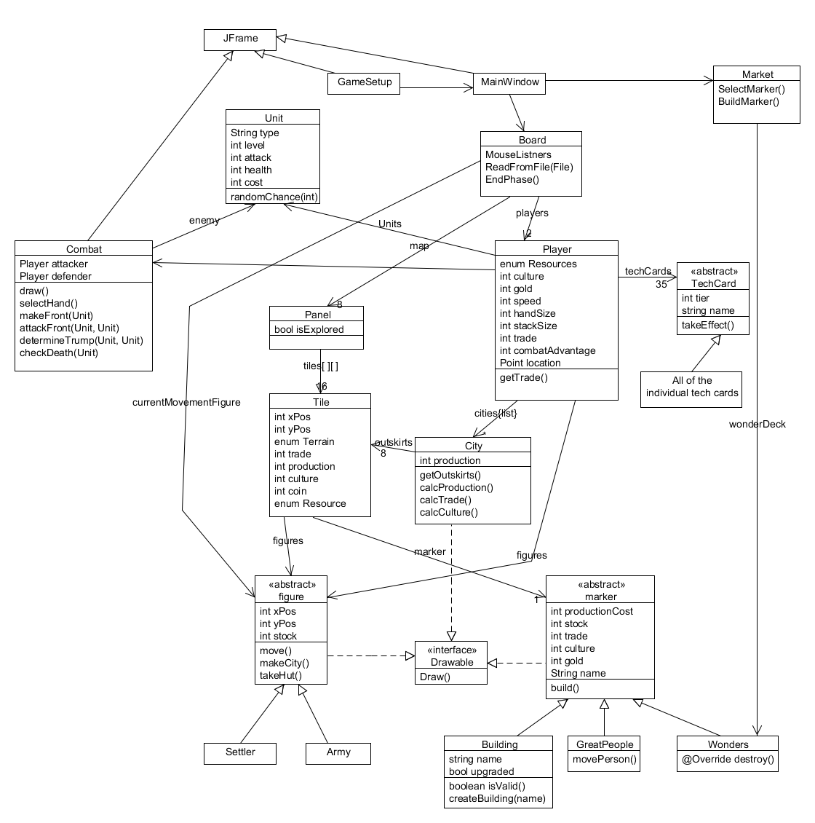

1. Code coverage is at 75.5%
2. Approximate lines of code per team member:
   1. Spencer: 1130
   2. Chris: 1670
   3. Josh: 1653
3. Summary of Overall Features:

The game consists of five phases, which we implemented while creating the game. First, however, a game setup window comes up. This window allows the two players to select a language and each of their civilizations. There are six civilizations to choose from. After those selections have been made, a new window is created, and this window holds all the important components. A majority of the window is made up of the actual game board (eight panels), of which two are explored and six are not. Also in this window are a series of buttons at the bottom. These buttons include specific player details, market details, a button to end the current player phase, the option to trade in culture and resources, and a quit button.

The first phase is called the Start of Turn phase. Here, the player can build new cities or change governments. Also, after each five-phase cycle, the starting player rotates, so during the second time through, the second player starts each phase.

The second phase is called the Trade phase. Here, the player automatically collects trade.

The third phase is called the City Management phase, and this is wear a majority of actions take place. A player’s city has the capability to perform a few different actions. One, the city can produce an item like a building or unit (this costs production, which the game automatically calculates). Also, it could instead decide to devote to the arts to gain culture or harvest a resource. The city can only perform one of these actions.

The fourth phase is the Movement phase, where each player can move his or her units over the board. Each unit (settler or army) can move up to the player’s speed amount. If a player lands on a hut, they gain a resource; if a player lands on a village, it initiates a battle, and if the player wins he or she gets a resource. If a player is on a square adjacent to an unexplored panel, has another move to use, and clicks on the panel, the panel becomes explored. In addition, if the player’s army lands on the same square as one of the other player’s units, combat is initiated once again.

The final phase is called the Research phase. Here, each player has the chance to buy a tech card. Each tech card has various benefits. There are five tiers of cards, and each tier costs more trade. There is only one card in the tier 5 category, and if the player buys it, he or she wins. The tech cards follow a pyramid structure. That is, you can only buy a tier 2, 3, 4, or 5 card if there is an empty space above the previous tier cards. For example, if the player has one tier 1 tech card, he or she cannot buy a tier 2, 3, 4, or 5 tech card. If he or she has two tier 2 tech cards, then he or she can buy a tier 2 tech card (following the pyramid structure, there is a space above the two adjacent tier 1 cards), but not a tier 3, 4, or 5 tech card. If the player has two tier 1 tech cards and one tier 2 tech card, then he or she can only buy another tier 1 tech card next turn, because there are no open spaces for any other higher tier tech card. This is the same case if there is more than 1 tier 2, 3, or 4 tech cards.

There are four ways to win the game: culture, economic, military, or tech. First, a player wins by culture if he or she has gained enough culture to advance to the end of the culture track (found at the bottom of the market details window). Second, a player can win by economic means if he or she has accumulated 15 gold coins. Coins can be gained by certain panel tiles as well as techs. Next, a player experiences a military victory if he or she conquers another player’s capital city. Finally, the player wins by tech if he or she buys the tier 5 tech card called Space Flight. To obtain the ability to buy this card, the player must buy at least five tier 1 cards, four tier 2 cards, three tier 3 cards, and two tier 4 cards.

All of the features listed in these phase descriptions are features we implemented.

1. Video link: <https://vimeo.com/66435292>